|  |
| --- |
| Designer Daily  *Serving Michigan State University since 2013*  Marc Lachance CEP 817: Learning Tech through Design  Spring Semester 2017 $1.25 |

**REFLECTING ON 100 DAYS IN CLASS**



*Michigan State Graduation – mlive.com*

It hasn't quite been 100 days in class but it is a time to reflect on what I have learned the past 15 weeks. This newspaper is organized much like one you'd pick up at the local gas station. It has witty headlines that have been slightly modified, comics, classified ads, entertainment, sports and a business section. Most importantly it has reflections on how I can incorporate learning technology through design in my profession.

|  |
| --- |
| **University News: Page 1 Classified Ads: Page 6**  **Local Reflection: Page 2 Entertainment: Page 7**  **Business: Page 3 Comics: Page 7**  **Sports: Page 4 Editor’s Note: Page 8**  **Weather: Page 5 References: Page 8** |
| **LOCAL REFLECTION** |

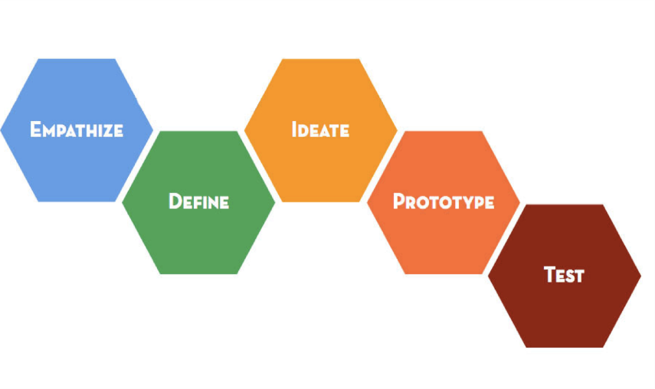

Coming into CEP 817, I have had only one other course dedicated to curriculum development. I like to plan and be a leader but designing was something that I struggled with. Learning the five modes of design gave me a map on how to navigate my way from coming up with a problem to designing, testing and finding a solution. The five modes are empathize, define, ideate, prototype and test. They are given in an order but there is no set starting point and the cycle can repeating many times. The Stanford University's d.school bootcamp bootleg is a great resource that any aspiring designer should use. They break down each of the modes with an explanation and why each is important. They also give several activities that you can do for each of the modes.

What I found out that I really enjoyed about designing is that it is a hands on activity. You need to be able to interact with users and be able to understand them. I never really put much thought into what others thought. In design, nothing is a stupid question. It's a let’s try to build it and test it to see if it works. If it doesn't, then you just go back to the drawing board and try again. This is really helpful and transfers nicely to education. Teachers build lessons daily and not everyone is a success. Teachers have the ability to reflect and see what worked and what they might need to tweak a little bit. A lesson plan should never be set in stone. It is a living, breathing document that should be reflected on constantly. Students do not learn now the same way they learned 10 years ago. It's amazing how much technology has changed the design process and how lessons are delivered.

This experience has changed the way that I will look at failure. A great quote A.P.J. Abdul Kalam is “if you FAIL, never give up because F.A.I.L mean First Attempt In Learning” (para. 14). When a prototype doesn't work out, it's not the end. There is always something to learn from each attempt. I found this out when I created a mini roulette wheel. I really liked the idea of finding everyday items around the house and used them to create a way that I could differentiate the way I taught. I only used paper, a permanent marker, pizza box and a marble. I thought that because the corners of the pizza box were angled that the marble would be able to go around the box. However, because the box was flat, it hard a hard time generating speed.

 Projects like the one mentioned above give me the confidence to try new things in the classroom. This course, at times, let me go outside of my comfort zone which will lead to me growing as a professional. These skills that I have learned in this course can be transferred across all aspects of my life. I plan to use this not only in the gymnasium but also in the hockey rink as a coach.

|  |
| --- |
| **BUSINESS** |

|  |
| --- |
| **SPORTS** |

**LACHANCE WINS COACH OF THE YEAR IN 2018!**



A coach always has the master plan when it comes to game day. However, the events leading up to the game are just as important. Being able to make the most of the ice time when you only have two hours a week can be the difference between a win and a loss. After taking this course, I want to reevaluate my practice plans for this upcoming season. I am the team’s leader but having input from the players and try to empathize with what works best for them as players, can make practices be more productive. Being able to design a practice that has a routine but does not get repetitive is a complicated balance. I want the players to have energy when they come to practice at 10 p.m. on Tuesdays and Thursdays. Interviewing players before the season about how they learn best as players can help me design my plans. I will also have brain storming sessions with my coaching staff so that we are all on the same page. If things don’t work out this upcoming season, I can try a new plan, learning from my mistakes and testing other systems.

|  |
| --- |
| **WEATHER** |

**STORMS TO HIT EAST LANSING**

 One of the most effective tools that helped me throughout the design process was brainstorming. This allowed me to lead discussions about our problem and connect with the users, other physical education teachers in our district. While brainstorming, we wanted to find ways that would give teachers experience in using Google Drive. This was an interesting topic because one of the reasons why we didn't have our fitness scores online was because some teachers did not feel comfortable with using technology. Some of the ways my coworker and I came up with were having teachers try it out on their own, have them watch how to videos on youtube, set them up with a mentor to guide them and by offering professional development opportunities throughout the school year.

Brainstorming can happen by yourself or with a group of people. One method of brainstorming is designing a mind map. To start, write the main idea or problem in the middle of the paper. That idea should invoke conversations within the group. In order to be productive, members should be encouraged to speak openly, listen to what everyone has to say and build on the ideas of others (pg. 28). Branches will stem off the main idea leading to mini ideas. Often times these too can be connected to form a web. One of the mini ideas that we came up with from our brainstorming session was how we could make the fitness scores accurate. We discussed another sort of storm to try to help us, bodystorming.

According to the Stanford Bootcamp, bodystorming is a “unique method that spans empathy work, ideation and prototyping” and we do it to “generate unexpected ideas that might not be realized by talking or sketching” (pg. 31). If I were to complete the design cycle again, I would try bodystorming to empathize with our students. We spent a lot of time trying to understand our users, the teachers. However, the students are also a key part in our fitness testing. Having our physical education teachers go through the fitness testing process as a student, can give us a better understanding of what the students experience when they complete the test. As teachers, we can talk about ways to improve our system but we need to physically walk through the process in order to fully understand it.

|  |
| --- |
| **CLASSIFIED ADS** |

**FRUSTRATED WITH TECHNOLOGY? – Millbury, MA**

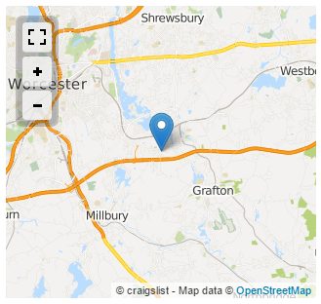

I am a tech savvy physical education teacher who is seeking others in the profession who are frustrated with technology.

Users should be able to meet at the Millbury Public Library once a month and have their own lap tops. Topics such as using technology in the gymnasium, inputting grades online, creating your own website and how to keep scores in an online database will be discussed

Please contact Mr. Lachance at lachan17@msu.edu

|  |
| --- |
| **ENTERTAINMENT** |



**MOVIE (RUNNING TIME) PLAYING**

[Tim Brown: Urging designers to think big](https://www.youtube.com/watch?v=UAinLaT42xY) (17 mins) 7:00 PM

[Design thinking and maximizing your student creative thinking](https://www.youtube.com/watch?v=nyt4YvXRRGA) (11 mins) 7:15 PM

[Steve Jobs: On Design](https://www.youtube.com/watch?v=sPfJQmpg5zk) (2 mins) 8:00 PM

[Design Thinking – The Power of Empathy](https://www.youtube.com/watch?v=747u3_Ms2tU) (3 mins) 8:30 PM

[The 5 Whys](https://www.youtube.com/watch?v=NBrFCHtoPRY) (2 mins) 9:00 PM

[Brainstorming Techniques](https://www.youtube.com/watch?v=-QIGWIxp_Co) (3 mins) 9:15 PM

[Rapid Prototyping: Google Glass](https://www.youtube.com/watch?v=d5_h1VuwD6g) (8 mins) 9:30 PM

[Design Thinking - Testing](https://www.youtube.com/watch?v=k5qUJId7V-o) (4 mins) 10:00 PM

|  |
| --- |
| **COMICS** |



|  |
| --- |
| **EDITOR’S NOTE** |

I took CEP 817 because I had already completed CEP 813 and CEP 820 and was looking to complete the Graduate Certificate in Online Teaching and Learning. It’s my last class before the capstone and I finish my Master’s Degree. Going into the class I did not know what I was getting myself into. I thought Learning Technology through Design might have been trying the latest and greatest technology in education. I didn’t really put much emphasize about design. It hindsight, I learned the most about design and how to build something from scratch. I now know that I can take chances and try new things and I don’t have to worry about being judged if I fail. I think that any new teacher should be required to take this course because it allows you to do things that you might be afraid to try. The knowledge I learned in this class will be passed to my students, players and my coworkers. Thank you for allowing me to step out of my comfort zone.

|  |
| --- |
| **REFERENCES** |

M Live retrieved from

<http://media.mlive.com/lansing-news/photo/msu-commencementjpg-55050ba829189984.jpg>

Quote Sigma retrieved from

http://www.quotesigma.com/famous-quotes-by-a-p-j-abdul-kalam/

MSU Today retrieved from

<http://msutoday.msu.edu/_/img/assets/2016/the-spartan-winter_tsdlg.jpg>

Standford’s Bootcamp Bootleg retrieved from

https://static1.squarespace.com/static/57c6b79629687fde090a0fdd/t/58890239db29d6cc6c3338f7/1485374014340/METHODCARDS-v3-slim.pdf

Videos From Class

<https://www.youtube.com/watch?v=UAinLaT42xY> – Tim Brown

<https://www.youtube.com/watch?v=nyt4YvXRRGA> – Co Barry

<https://www.youtube.com/watch?v=sPfJQmpg5zk> – Steve Jobs

<https://www.youtube.com/watch?v=747u3_Ms2tU> – Empathy

<https://www.youtube.com/watch?v=NBrFCHtoPRY> – 5 Whys

<https://www.youtube.com/watch?v=-QIGWIxp_Co> brainstorming

<https://www.youtube.com/watch?v=d5_h1VuwD6g> – Google Glass

<https://www.youtube.com/watch?v=k5qUJId7V-o> Design Thinking