Marc Lachance

Michigan State University

Final Problem of Practice Report

April 2017

|  |
| --- |
| **INTRODUCTION** |

At the beginning of CEP 817, we were asked to present a problem involving technology in our everyday practice. One of our main assessments that we do throughout the school year in physical education is the fitness tests. We complete them once each term for a total of three testing periods. Scores in the past were either kept in grade books or folders and would not be passed on to other schools. If these scores were misplaced or for some reason got destroyed, there would be no way to recreate the scores. My solution and problem of practice for the semester was to find a way to be able to store fitness test results online.

During the next 15 weeks, we learned about the five stages of the Stanford Design Thinking Model: empathize, define, ideate, prototype and test. Along the way, we had labs that helped us find out who are users were, defined our problem, created environments where we could get ideas from other people and objects, created our database and lastly had our users test what we created. Below is a summary of going through the design process once.

|  |
| --- |
| **EMPATHIZE** |

After coming up with a problem that I wanted to solve, I started to make a Journey Map (Appendix A) to keep me on track with the design process. I wanted to get an understanding of what the other physical education teachers in the district thought about doing more with the fitness scores. I am new to the district and my thoughts and visions of how we should use the data could be different than theirs. I knew that I did not want to collect data and then not use it. When talking with my coworker and assistant principal, they both seemed very supportive of the project because it would create dialogue between the three schools in the district and it would make the data that we were collecting meaningful. I asked my coworker a few questions and recorded his answers (Appendix B) about his experience with technology and how he thought that this database could benefit the department. We both agreed that we could use the data to drive instruction and work on areas that tested poorly throughout the year.

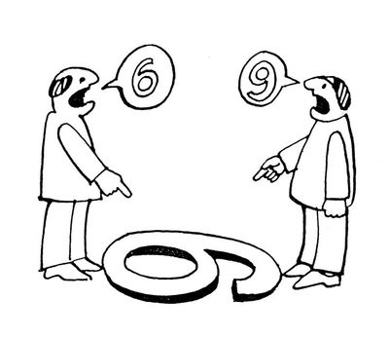

**Figure 1** – *Seeing Things From Different Points of View*

|  |
| --- |
| **DEFINE** |

Next, we had to define our problem and find out the root of it. I completed a series of helpful activities such as the five whys (Appendix C), a why/how ladder (Appendix D), a point of view want ad (Appendix E) and a point of view mad lab (Appendix F). During this mode I found out that one of the main reasons why the scores have not been kept online is because some of the teachers in our department did not feel comfortable using technology. One thing that our district could do to help with this fear is to have professional development opportunities to learn more about Google Drive and all its function. During this mode, we also create a rough draft of our problem statement.

**Figure 2** *– Problem Statement*

|  |
| --- |
| **IDEATE** |

We were able to take a step back during the ideate mode of the process to collaborate with our users and take a look at the big picture. A great way to collaborate with a group is through a brainstorming session. I was able to talk with my coworker for thirty minutes about moving fitness scores to an online tracker. We focused on how it was important to have accurate fitness scores and how the online tracker could help with that. We also weighed the pros and cons of different systems to host our online database.

Another way to get ideas is through a thought incubation period. This is a time to step away and take your mind off the problem at task. I was able to play basketball and one of the main organizational pieces of the database came to my mind: color coding the tests. We had five red, orange, yellow, green and blue basketballs on a rack to keep track of them and to know if any of them were missing at the end of a class. Having the tests color coded would let the users know that the data was changing to a new test because it was highlighted with a new color. You can see my incubation notes in Appendix G. These notes were in my pocket throughout the module and I would write down any notes that came to mind throughout the day. With these notes, I was able to start thinking about what my prototype would look like.

|  |
| --- |
| **PROTOTYPE** |

In the prototype phase, the database started to become more than just an idea. I was able to physically see it through drawings. I was then able to use the computer to create my database on Google Sheets. I used a lot of the ideas that I thought of during the ideate stage and only focused on one grade to start. I was able to save time by downloading the class rosters from X2 and inputting them into the database. I separated the grade by homerooms and had the five fitness tests going horizontally across the screen. Being able to color code the cells made it easy to tell the different test scores apart. Each test had three columns, one for each trimester.

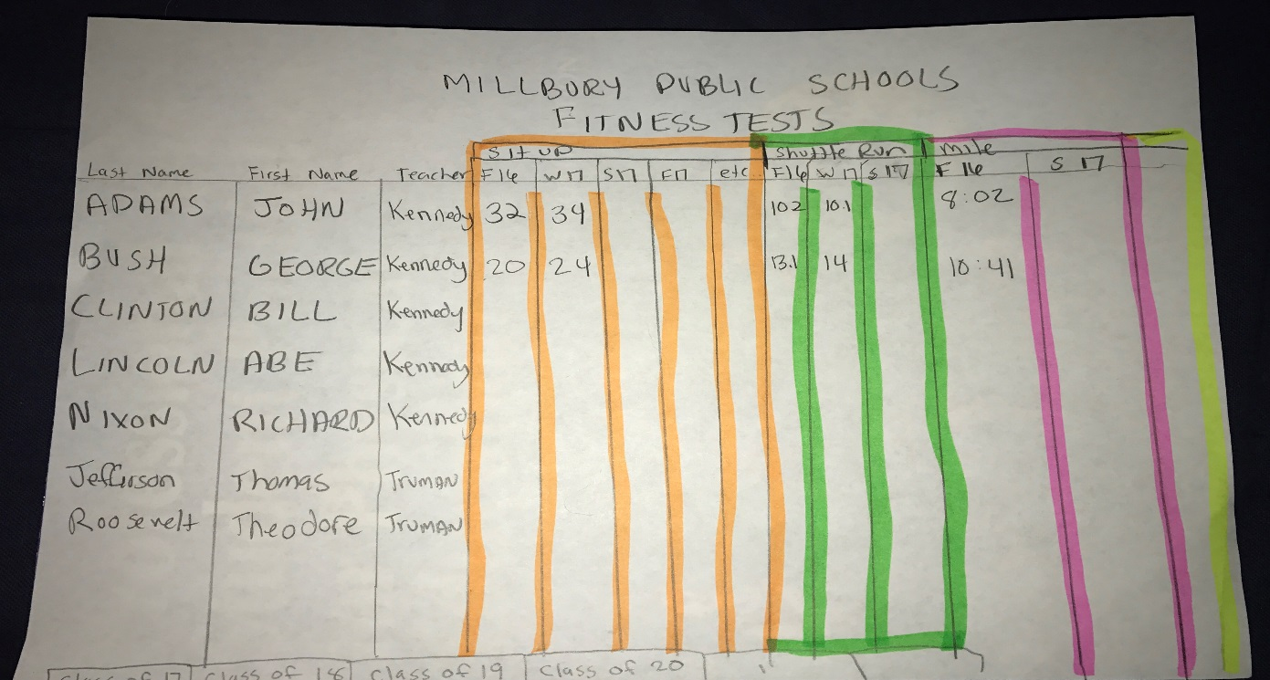 **Figure 3** – *Drawing of Prototype*

|  |
| --- |
| **TEST** |

Even though testing is the final stage in the design process, my solution is still considered a rough draft. Often times, a solution goes through the cycle a few times before it becomes a finished product. This is the stage that allows other users to be hands on with your solution and allows them to see possible flaws that you might be blind to. To test my prototype, I asked my coworker to input one class roster and its fitness scores into our database. I gave him a basic checklist of the tasks and observed him while he entered his scores. After completing the tasks, we sat down for a short interview so I could gather feedback about his experience using the database. A full testing report can be found in Appendix H

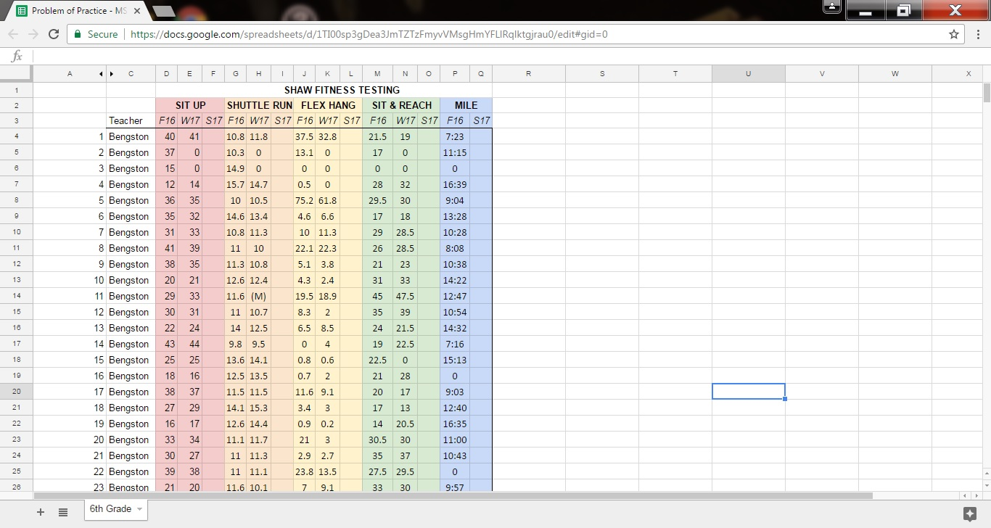

**Figure 4** *– Picture of test*

|  |
| --- |
| **CONCLUSION** |

In conclusion, I have learned a lot about the whole process of design. Before this class, I would have looked at a problem and I would have searched for a simple solution. Now, I know that each of the five stages are equally important and that even after finishing all five steps, it still may need to go through the cycle a few more times. I would not have taken the time to research my users or let certain ideas incubate. Sometimes taking a break from a problem and looking at it with a fresh set of eyes can bring new ideas.

As a designer, I like to be in charge and be a leader. Throughout this process, I was able to brainstorm with other teachers and interview my coworker to get a wide range of ideas. This was a good balance for me because I was able to lead the sessions, which was in my comfort zone, but I was also able to sit back and listen to what others had to say. If there was an area where someone else had more expertise, they could take charge and lead the discussion. When facing problems in the future, I know that I will follow guidelines and use some of the activities used throughout this course.